Understanding Windows Event Logs for Undergraduate Students
Windows Event Logs are an essential part of system monitoring and troubleshooting in Windows operating systems. These logs record significant system events, application activities, and security-related actions, helping IT professionals and users diagnose issues and track system behavior.

1. What Are Windows Event Logs?
Windows Event Logs are a collection of records that store information about events happening within the Windows operating system. These events include:
- System startup and shutdown
- User logins and logouts
- Application crashes
- Security breaches and warnings
Each event is stored with a timestamp and details such as the source, event ID, and severity level.

2. How to Access Windows Event Logs
You can access Windows Event Logs using the Event Viewer, a built-in Windows tool.
Steps to Open Event Viewer:
- Press Win + R, type eventvwr.msc, and hit Enter.
- The Event Viewer window will open, displaying different log categories.
Alternatively, you can open it by:
- Searching for Event Viewer in the Windows Start menu.
- Going to Control Panel > Administrative Tools > Event Viewer.
Event Viewer Interface
The Event Viewer is divided into several sections:
- Event Viewer (Local) – The main dashboard
- Windows Logs – Contains key system logs
- Applications and Services Logs – Includes logs for specific applications
- Custom Views – Allows users to create filters for specific logs
📷 Event Viewer Interface Example:
(I will generate an image of this for better understanding.)

3. Types of Windows Event Logs
Windows categorizes events into five primary log types:
A. Application Logs
- Records events related to software applications.
- Example: If Microsoft Word crashes, the event is logged here.
B. Security Logs
- Tracks login attempts, system access, and security-related changes.
- Example: A failed login attempt due to an incorrect password.
C. System Logs
- Contains logs related to Windows system components.
- Example: Driver failures, unexpected shutdowns, or hardware issues.
D. Setup Logs
- Stores installation and configuration-related logs.
- Example: Windows Update installations and setup failures.
E. Forwarded Events
- Receives logs from other computers in a network (useful in enterprise environments).

4. Event Log Structure
Each log entry consists of:
- Event ID: A unique number identifying the event type (e.g., 4624 for successful login).
- Source: The component generating the event (e.g., "Security" or "Application Error").
- Level: Severity of the event (Information, Warning, Error, Critical).
- User: The account associated with the event.
- Timestamp: The exact date and time the event occurred.

5. How to Analyze Event Logs?
A. Filtering Logs
- In Event Viewer, click Action > Filter Current Log to view specific event types.
- You can filter by Event ID, date, or source.
B. Searching for Specific Events
- Use the Find option (Ctrl + F) to locate events by keywords.
C. Exporting Logs
- Right-click a log and select Save All Events As… to save logs for analysis.

6. Why Are Windows Event Logs Important?
- Troubleshooting: Identify application crashes and hardware failures.
- Security Monitoring: Detect unauthorized access and potential threats.
- System Performance Tracking: Monitor system health and uptime.

How to Save Windows Event Logs
- In Windows 11, 10, 8.1, or 8:
  - Press the Window Key
  - Type: Event Viewer
  - Select View Event Logs
Select the type of logs that you must export:
- Windows 11, 10, 8.1, 8, or 7:
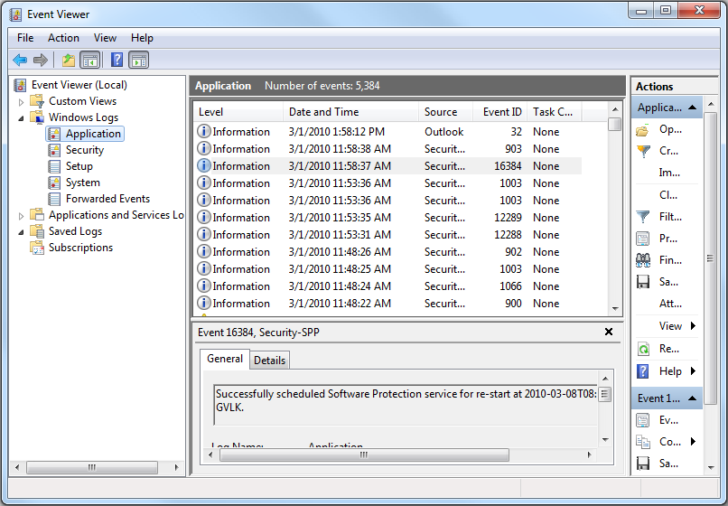
Save the log:
- Windows 11, 10, 8.1, 8, or 7: Action - > Save All Events As….
